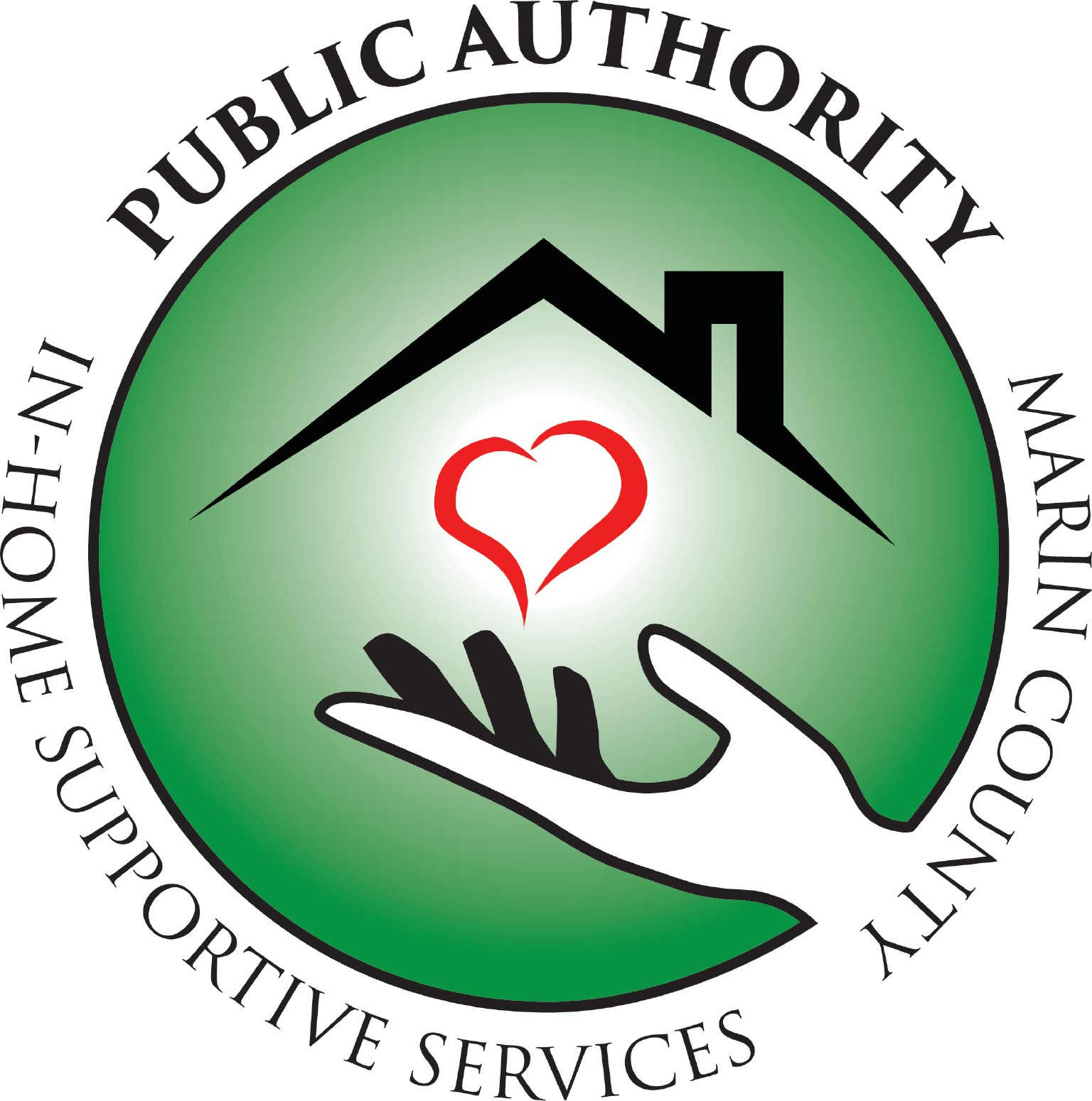
Special Board Meeting

Agenda and Notice

Nov. 7th 2022 at 11AM

Meeting will be recorded for minutes purposes

NOTICE IS GIVEN that the IHSS Public Authority for Marin County Board of Directors has called a Special Meeting in accordance with Government Code Section 54956. The Special Meeting will consist of the open session and a closed session commencing on Monday, November 7, 2022 at 11:00 a.m. at 70 Skyview Terrace Building B and by Zoom at the following link. The business to be transacted at the Special Meeting consists of the matters described below. No other business shall be considered at the Special Meeting.

This Special Board Meeting will be held at
70 Skyview Terrace, Building B
San Rafael, CA 94903
and via Zoom at the following link which is open to the public:
https://us02web.zoom.us/j/82870135435?pwd=T1NKM2ZZVTRCRWNaK1cwS1JiOHpwZz09

11:00AM – 12:00PM

Call to Order
- Open Time for Public Comment.  (Public comments are limited to three minutes per person. The public is invited to make comments on any other items of public interest not listed on the Agenda.)  - Adjourn for Closed Session  Conference with Legal Counsel - Anticipated Litigation Government Code Section 54956.9, subdivision (d)(2).  Number of Potential Cases: One (1).  - Reconvene to Open Session  Publicly report specified closed session actions and the vote taken on those actions, if any  - Motion to Approve Hybrid Meetings in accordance with Government Code Section 54953(e)(1).  - Adjourn | Harris  Harris  Harris
Harris
Harris

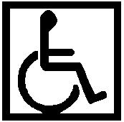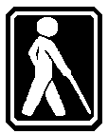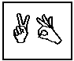

All In-Home Supportive Services (IHSS) Public Authority of Marin public meetings are conducted in accessible locations. If you require American Sign Language interpreters, assistive listening devices or other accommodations to participate in this meeting, these may be requested by calling (415) 499-1024 ext. 104 at least 72 hours in advance. Copies of documents used in this meeting are available in accessible formats upon written request.

