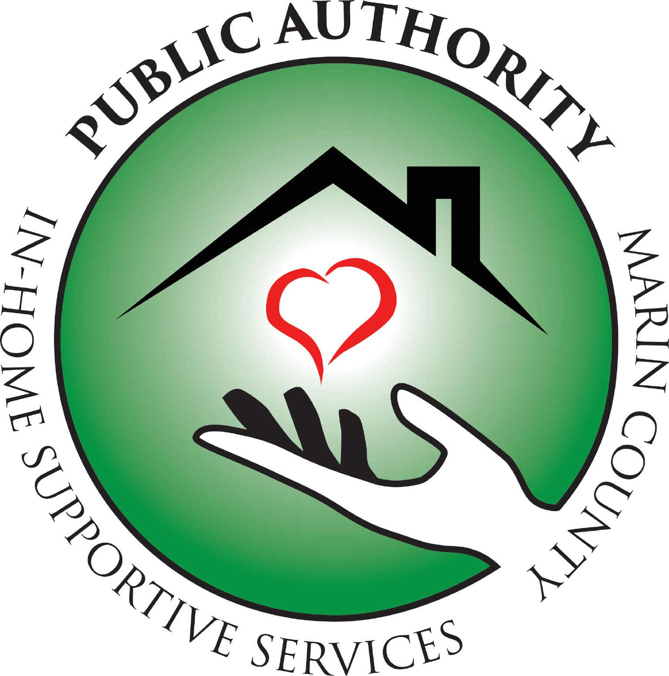
Special Board Meeting

Agenda and Notice

Nov. 16, 2022 at 3:00 PM

Meeting will be recorded for minutes purposes

NOTICE IS GIVEN that the IHSS Public Authority for Marin County Board of Directors has called a Special Meeting in accordance with Government Code Section 54956. The Special Meeting will commence on Wednesday, November 16, 2022 at 3:00 p.m. at 70 Skyview Terrace Building B and by Zoom at the following link. The business to be transacted at the Special Meeting consists of the matters described below. No other business shall be considered at the Special Meeting.

This Special Board Meeting will be held at
70 Skyview Terrace, Building B
San Rafael, CA 94903
and via Zoom at the following link which is open to the public:
https://us02web.zoom.us/j/82870135435?pwd=T1NKM2ZZVTRCRWNaK1cwS1JiOHpwZz09

3:00PM – 5:00PM

Call to Order | Harris
- Introduce Board Members, guests and Members of the Public  - Consent Calendar (All items on the consent calendar may be approved by one motion of the Governing Board unless one-member requests an item be removed).  Recommended Action: Approve  - Minutes of Nov. 7th, 2022  - Agenda of Nov. 16^{th,} 2022  - Open Time for Public Comment.  (Public comments are limited to three minutes per person. The public is invited to make comments on any other items of public interest not listed on the Agenda.)  - Adjourn for Closed Session  - Public Employee Performance Evaluation (Government Code Section 54957(b)(1)).  - Conference with Labor Negotiators (Government Code Section 54957.6)  Designated Representative: Michael Harris, Board Chair  Unrepresented Employee: Executive Director  - Reconvene to Open Session  Publicly report specified closed session actions and the vote taken on those actions, if any  - Adjourn | Harris  Harris  Harris  Harris
 | Harris
 | Harris

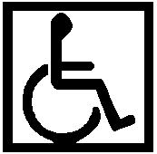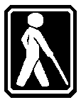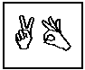

All In-Home Supportive Services (IHSS) Public Authority of Marin public meetings are conducted in accessible locations. If you require American Sign Language interpreters, assistive listening devices or other accommodations to participate in this meeting, these may be requested by calling (415) 499-1024 ext. 104 at least 72 hours in advance. Copies of documents used in this meeting are available in accessible formats upon written request.

